21th June, 2021
Report

Ecosystem Studies of Sub-arctic and Arctic Seas Annual Science Meeting 2021

Title: Linking past and present marine ecosystems to inform future fisheries and aquaculture
Meeting style: Remote
Main location: Arctic Research Center, Hokkaido University
Date: 30th May-3rd June, 2021
Local Organizing Committee: Naomi Harada (Japan Agency for Marine Science and Technology: JAMSTEC), Toru Hirawake (National Institute of Polar Research), Sei-ichi Saito & Taka Hirata (Hokkaido University)

Ecosystem Studies of Subarctic and Arctic Seas (ESSAS), one of the regional programs of the Integrated Marine Biosphere Research (IMBeR). The goal of the ESSAS Program is to compare, quantify and predict the impact of climate variability on the productivity and sustainability of Subarctic and Arctic marine ecosystems. Although the ESSAS Annual Science Meeting (ASM) scheduled in June 2020 had to be canceled due to COVID-19, the 2021 ASM was held as a webinar (web seminar) style meeting. The registration fee was free. The URL of the web conference was sent to those who have registered for participation by email the day before the event. The program is as follows:

Program: (Date and time in Japan Standard Time)

30 May (Sun)
18:00–19:00 (Live, in Japanese)
Public session “Mammal living in the sea: fur seal, seal, dolphin, whale, and human being” by Dr. Yoko Mitani, Associate Prof., Hokkaido University

A public lecture was successfully held on 30th May as an event of the 2021 annual science meeting of "Ecosystem Studies of Subarctic and Arctic Seas" (ESSAS) with a co-sponsorship of ArCS-II, J-ARC Net, Arctic Research Center of Hokkaido University and JAMSTEC. Although the lecture was delivered through online, we were able to have 103 participants. Dr. Mitani introduced mammals found around Hokkaido and the north Pacific and presented a long history of change in biomasses of mammals that have been highly impacted by human activities. A lot of questions and comments from participants to this impressive talk were raised after the lecture. Participants developed interest in studies in the Arctic and sub-Arctic ecosystem.

31 May (Mon)
Contribution from ESSAS community to the local communities in Japan

Live (L), In Japanese (J), In English (E),
Simultaneous translation of Japanese-English (J-E or E-J), On-demand contents in English (ODE)

09:00–10:25 JST = 17:00–18:25 Pacific Daylight Time = 02:00–03:25 Central European Summer Time
13:00–15:00 JST = 21:00–23:00 PDT = 06:00–08:00 CEST

09:00–09:05 Welcome address by Prof. Fukamachi, Director of Arctic Research Center, Hokkaido University (L, J, J-E)
09:10–09:35 Keynote talk 1 “The song of the spring, the story of the wind: Relationships among air, sea, ice, people and Pacific herring (Clupea pallasii) in the past, present and future” Dr. Naoki Tojo Assistant Prof. Hokkaido University
(L, J, ODE)
09:35–10:00 Keynote talk 2 “Assessing and managing fish stocks in a rapidly changing environment” Dr. Franz Mueter, Professor of Fisheries, University of Alaska Fairbanks (L, E, E-J)
10:00–10:25 Keynote talk 3 “Community resilience under rapid socio-environmental change. But how can we enhance it?” Dr. Aoi Sugimoto, Researcher, National Research Institute of Fisheries Science (L, J, ODE)
10:25–13:00 Lunch break
13:00–15:00 Discussion led by Prof. Mitsutaku Makino (University of Tokyo) (Identify key issues & challenges; identify ways to enhance collaborations between scientists and stakeholders)
(L, J, J-E/E-J)

The environmental stressors surrounding marine lives such as global warming, acidification, anoxia, and changes in nutrients are progressing to severe conditions. In addition, such changes in climate and environment are thought to have an impact on the culture that has been nurtured in the northern area of Japan, Hokkaido and the northeastern part of Tohoku. Under this situation, how will climate change from the subarctic to the Arctic affect fishery resources and local culture? How can our society respond? How can we (scientists and stakeholders) communicate to resolve the problems responding on the demands of society? A stakeholder meeting was held for the purpose of discussing the direction. Focusing on the fisheries and aquaculture industries, which are the main industries of Hokkaido and northern Tohoku area, individuals and various groups involved in the fisheries and aquaculture industries, people in the policy field such as local governments, the national institute, people in companies participated. The purpose of the stakeholder meeting was to deliver into collaboration with researchers in the natural sciences and social sciences. The number of participants in the discussion was 14, and the results of the discussion were summarized as follows.
- Problem awareness/interest: There is not much difference between the site/field community and the science community. In particular, fisheries science is trying to meet on-site needs, and cities, prefectures, and extension workers play an important role in drawing up on-site needs (research needs survey). The role of science is also to raise awareness of potential problems in future (marine plastics, etc.).
- Information needs: The field community wants amount of resources, their distribution and migration, understanding of spatiotemporal changes in fishing grounds, real-time information and future forecast information (directly linked to finance and financing) → In order for researchers to respond to that, especially when making predictions, we need as much information as possible and real-time information (such as the distribution of fish forecasts).
- Cooperation between stakeholders: Cooperation with fishermen in data collection and monitoring, immediate distribution of information, sharing of forecast and verification, information dissemination (NPO is also important). The important thing is to find issues that are common to everyone, work on them together, and focus on what you can do. It is also necessary to actively visit the Fisheries Experiment Station from the site/field community and get close to it. Sharing fish finder data is also effective through horizontal collaboration with fishermen (understanding when disclosing fish finder data to others is required) .
- Possibility of new technology: Sharing and transmission using satellite, ICT, AI, automation, and SNS.
- A lot of unused information: Real-time information through operations up to 1000m (Ishinomaki), food culture, and unused dark data, so it is necessary to create a database. Annual report published by government and agency can also be used more effectively.
- Importance of communication: How to make the information easy to use and understand in the field community? Transmission according to the needs. Places such as public lectures and science cafes are also effective. Scientists must be able to explain in an easy-to-understand manner. There is also a need for a connecting role on the research side. Science communication specialists and systems are also required.

After the stakeholder meeting, follow-up discussions continued via e-mail, and both the field side and the scientist side agreed that the selection of personnel was extremely important. It was recognized that it is important to select the most suitable people who will be key persons from each field/region, and to have those people face the same direction and proceed with the policy of "Sampo Yoshi" which means that everybody become happy.

1 June (Tue)
Conducted twice in the morning and afternoon for 3 hours each.
5:00–8:00 JST = (13:00–16:00 PDT = 22:00–1:00 CEST)
15:00–18:00 JST = (23:00–2:00 PDT = 8:00–11:00 CEST)
Oral presentation （Please see Abstract book for presenter’s name and title）
05:00–06:15 Session A (15 min x 5 talks)
06:15–06:35 Break
06:35–07:50 Session B (15 min x 5 talks)
07:50–15:00 Break & Lunch
15:00–16:15 Session C (15 min x 5 talks)
16:15–16:35 Break
16:35–17:50 Session D (15 min x 5 talks)

The number of participants was about 30 people in each session despite the early morning or late night hours depending on the countries. Participating countries are Canada, Japan, South Korea, France and China. There was a lively presentation and Q & A session. However, there were some presenters, such as participants from Europe, who could not participate on the wrong date (the LOC ask presenters to submit the presentation file with voice beforehand, so there was no problem in the progress of program). Regarding the poster session, there were 11 entries (participating countries: Mozambique, Canada, Japan, China, Bangladesh, Australia), and the website was released from May 25 so that it can be viewed on demand. Questions were also accepted on the website.

2 June (Wed)
Session1 06:00-08:00 JST (= 14:00–16:00 PDT = 23:00–1:00 CEST）
Session 2 15:00-17:00 JST(= 23:00–1:00PDT= 8:00–10:00 CEST)

A joint workshop of ESSAS Working Group Paleo ESSAS (Paleoclimatology & Archeology) and Analogue Art (Ocean Acidification) was held. Ben Fitzhugh and Samuel Rastrick, who are the representatives of each working group, took the lead role in the meeting, and concrete discussions on future collaboration were held.

09:00-09:30 Introduction session for poster presentation
13 people participated, mainly the presenters of the poster session. Seven posters were introduced in 2-3 minutes each. See the abstract book for the presenters and titles of each poster.

3 June (Thu)
05:00–08:00 JST (=13:00–16:00 PDT =22:00–1:00 CEST)
ESSAS Science Steering Committee Meeting
Science steering committee members from Japan, Canada, Norway, the United States, Denmark, and South Korea and four working group leaders attended. We carried out activity reports for 2020 in each country, annual report of ESSAS to be submitted to IMBeR which is the mother organization, enhancement of websites, confirmation of host countries of ASM in 2022 (Seattle / USA) and 2023 (Tromso / Norway). 2024 is the year of the Open Science Meeting (OSM) once every six years. Since OSM has not been held in Japan yet, it is expected to be held in Japan. In 2025, Halifax Canada is a candidate host.

Schedule of ESSAS ASM 2021
 | 30 May (Sun) | 31 May (Mon) | 1 June (Tue) | 2 June (Wed) | 3 June (Thu)
Morning |  | Keynote talk | Oral session | Working group session/ Introduction session for poster presentation | ESSAS SSC meeting
After noon | Public lecture | Stakeholder meeting | Oral session | Working group session
Host place | Arctic Research Center, Hokkaido University | Arctic Research Center, Hokkaido University | Arctic Research Center, Hokkaido University | Arctic Research Center, Hokkaido University | Arctic Research Center, Hokkaido University

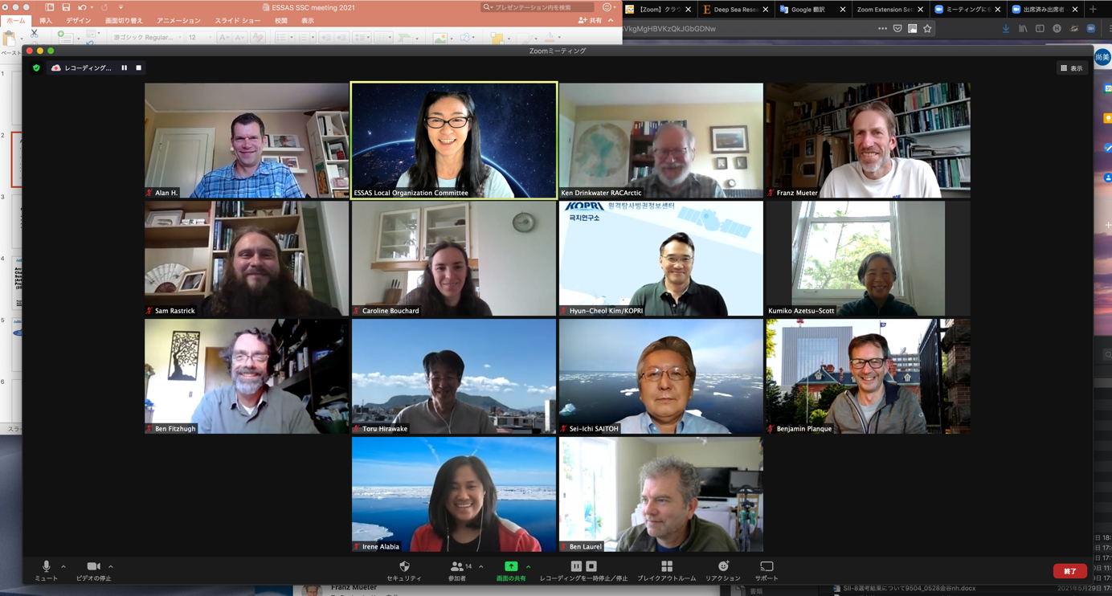
Photo：ESSAS SSC meeting

